**STW220CT: Data and Information Retrieval**

**MongoDB and Graph DB Assignment**

**Due Date: 2nd July 2021, 11:30PM**

**Total Marks: 75**

**Upload your assignment in .pdf format in the given link below.**

**Campus link: https://campus.softwarica.edu.np/modules/data-information-and-retrieval/data-visualisation**

**Task 1: MongoDB (30 Marks)**

**Games data**

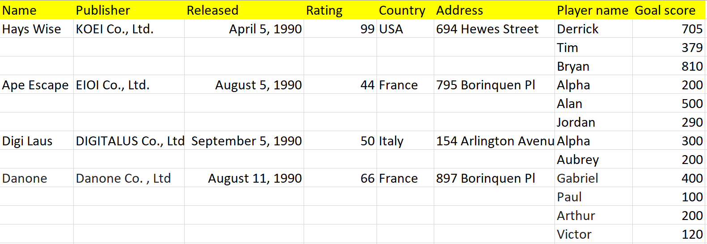

1. Create a database named <<YourName_Games>> and a collection named <<YourName_CoventryID_Games>> and insert the above data. [5]
2. Count the number of players in Hays Wise. [5]
3. Remove the player “Alpha" from Ape Escape. [5]
4. Update player name “Jordan” to “Michael” and score to 300. [5]
5. Show all the number of players with their publisher name. [5]
6. Show total goals scored by each country name. [5]

**Task 2: Development of a graph database for a given dataset (45 Marks)**

Find “**Task_2_PremierLeauge_2019.csv**” file. The dataset contains information about the **English Premier League (EPL)** matches. You are expected to design and create a graph database to visualize the dataset and to answer the following queries:

1. Create a Data Model diagram for “**Task_2_PremierLeauge_2019.csv**” dataset. [5]
2. Create nodes and relationship according to the Data Model which you have created in question no 1. [10]
3. Show all the EPL team involved in the season. [3]
4. Count all the matches refereed by each referee. [5]
5. Who refereed the most matches? [7]
6. How many matches “Arsenal” won as the away team? [5]
7. Display all the matches that “Man United” lost. [5]
8. Display all matches that “Liverpool” won but were down in the first half. [5]

**Note:**

Find “**Task 2 - Match Keywords.txt**” file for the keywords used in the EPL matches.